Laboratory work #2

Distributed banking system

Student: CAO Xinyang  
Student HDU ID: 20321308

Mail:

c.x_yang@foxmail.com

Screenshot or copy with mail with “Passed”:

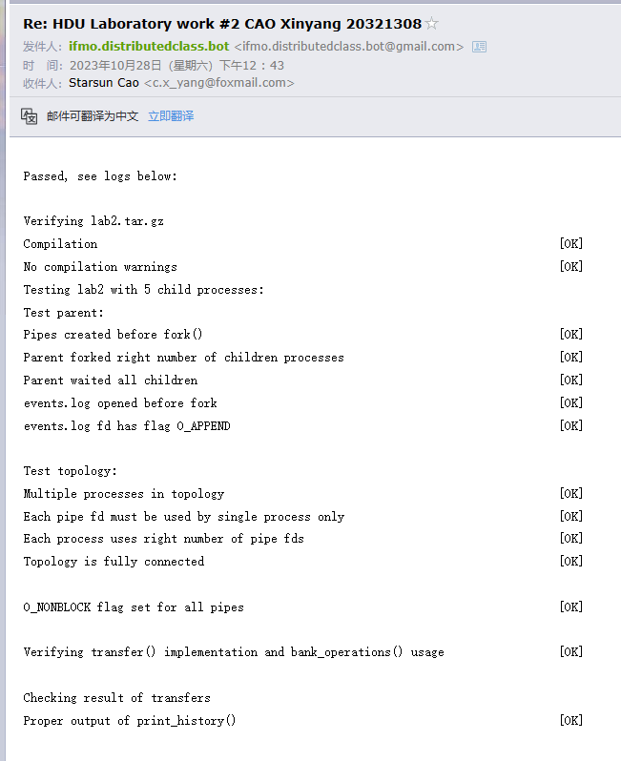

Control questions:

1. Transfer request. Is it synchronous or asynchronous in our model from point of client? Why?  
What is difference between synchronous and asynchronous operations?

Answer:

Asynchronous. Clients kick off transfers and carry on with their tasks without having to wait for the transfers to finish. Unlike synchronous operations that hold up clients until they get immediate results, asynchronous operations let clients move forward and receive results at a later time. This method boosts both the efficiency and responsiveness of the system in a distributed setting.

2. What will happened, if transfer operations isn’t instantaneous?  
Can we calculate total amount of money at each moment of time? Why?

Answer:

When transfer operations isn’t instantaneous, determining the total sum of money at any given point becomes a complex task. The presence of unfinished transfers and the variability in execution times can lead to discrepancies in account balances. The sequence in which transfers take place affects the state of the system, adding complexity to the real-time balance calculation. The non-immediate nature of transfers keeps the system in a state of continuous change, making it impractical to compute an exact total balance.

3. Make an experiment. You can find in header banking.h function get_physical_time_skew(). Use it instead of get_physical_time(). This function provides non-synchronized clocks. Why result of execution is different?  
Answer should contain output table.

Answer:

Replacing get_physical_time() with get_physical_time_skew() results in unsynchronized clocks, leading to variations in the execution outcomes. Each process now operates its own clock with different time skews, causing inconsistencies in event timestamps. This impacts the sequence of event handling and message ordering, potentially leading to unforeseen behavior and coordination problems in distributed systems. The lack of synchronized clocks underscores the difficulties in preserving event sequencing and synchronization in such settings.

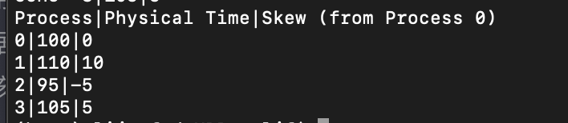

Source code:

#include <stdio.h>

#include <unistd.h>

#include <string.h>

#include <sys/types.h>

#include "labs_headers/message.h"

#include "labs_headers/log.h"

#include "labs_headers/process.h"

#include "labs_headers/banking.h"

void update_history(BalanceHistory *history, timestamp_t time, balance_t amount)

{

    int last_time = history->s_history[history->s_history_len - 1].s_time;

    int last_balance = history->s_history[history->s_history_len - 1].s_balance;

    for (int i = last_time + 1; i < time; i++)

    {

        history->s_history[history->s_history_len].s_time = i;

        history->s_history[history->s_history_len].s_balance = last_balance;

        history->s_history[history->s_history_len].s_balance_pending_in = 0;

        history->s_history_len++;

    }

    history->s_history[history->s_history_len].s_balance = amount;

    history->s_history[history->s_history_len].s_time = time;

    history->s_history[history->s_history_len].s_balance_pending_in = 0;

    history->s_history_len++;

}

balance_t now_balance(BalanceHistory *history)

{

    return history->s_history[history->s_history_len - 1].s_balance;

}

void parent_work(int count_nodes)

{

    AllHistory all_history;

    all_history.s_history_len = count_nodes - 1;

    /* STUDENT IMPLEMENTATION STARTED */

    /* Implement starting synchronization */

    for (int i = 1; i < count_nodes; i++)

    {

        Message msg;

        receive(i, &msg);

        if (msg.s_header.s_magic == MESSAGE_MAGIC && msg.s_header.s_type == STARTED)

        {

            continue;

        }

    }

    /* Useful work */

    bank_operations(count_nodes - 1);

    /* Implement finishing synchronization and collecting AllHistory */

    Message msg;

    fill_message(&msg, STOP, get_physical_time(), NULL, 0);

    send_multicast(&msg);

    for (int i = 1; i < count_nodes; i++)

    {

        Message msg;

        receive(i, &msg);

        if (msg.s_header.s_magic == MESSAGE_MAGIC && msg.s_header.s_type == DONE)

        {

            continue;

        }

    }

    for (int i = 1; i < count_nodes; i++)

    {

        Message msg;

        receive(i, &msg);

        if (msg.s_header.s_magic == MESSAGE_MAGIC && msg.s_header.s_type == BALANCE_HISTORY)

        {

            BalanceHistory *history = (BalanceHistory *)msg.s_payload;

            memcpy(&all_history.s_history[i - 1], history,msg.s_header.s_payload_len);

        }

    }

    print_history(&all_history);

    return;

}

void child_work(struct child_arguments args)

{

    /* Child arguments */

    local_id self_id = args.self_id;

    int count_nodes = args.count_nodes;

    uint8_t balance = args.balance;

    /* BalanceHistory initialization */

    BalanceHistory history;

    history.s_history_len = 1;

    history.s_id = self_id;

    memset(history.s_history, 0, sizeof(history.s_history));

    history.s_history[0].s_balance = balance;

    for (int i = 0; i < MAX_T; ++i) {

        history.s_history[i].s_time = i;

    }

    /* System process identifiers used for logs */

    pid_t self_pid = getpid();

    pid_t parent_pid = getppid();

    /* STUDENT IMPLEMENTATION STARTED */

    char buf[BUF_SIZE];

    Message msg;

    timestamp_t current = get_physical_time();

    snprintf(buf, BUF_SIZE, log_started_fmt, current, self_id, self_pid, parent_pid, balance);

    fill_message(&msg, STARTED, current, buf, strlen(buf));

    send_multicast(&msg);

    shared_logger(buf);

    Message recv_msg;

    int cnt = 0;

    for (int i = 1; i < count_nodes; i++) {

        if (i == self_id)

            continue;

        receive(i, &recv_msg);

        if (recv_msg.s_header.s_magic == MESSAGE_MAGIC && recv_msg.s_header.s_type == STARTED) {

            cnt++;

        }

    }

    if (cnt == count_nodes - 2) {

        current = get_physical_time();

        snprintf(buf, BUF_SIZE, log_received_all_started_fmt, current, self_id);

        shared_logger(buf);

    }

    cnt = 0;

    while (true) {

        Message req_msg;

        receive_any(&req_msg);

        if (req_msg.s_header.s_magic == MESSAGE_MAGIC && req_msg.s_header.s_type == TRANSFER)

        {

            TransferOrder *order = (TransferOrder *)req_msg.s_payload;

            if (order->s_src == self_id) {

                current = get_physical_time();

                update_history(&history, current, now_balance(&history) - order->s_amount);

                snprintf(buf, BUF_SIZE, log_transfer_out_fmt, current, self_id, order->s_amount, order->s_dst);

                shared_logger(buf);

                Message response_msg;

                fill_message(&response_msg, TRANSFER, current, order, strlen((const char*)order));

                send(order->s_dst, &response_msg);

            } else if (order->s_dst == self_id) {

                current = get_physical_time();

                update_history(&history, current, now_balance(&history) + order->s_amount);

                snprintf(buf, BUF_SIZE, log_transfer_in_fmt, current, self_id, order->s_amount, order->s_src);

                shared_logger(buf);

                Message response_msg;

                fill_message(&response_msg, ACK, current, NULL, 0);

                send(0, &response_msg);

            }

        } else if (req_msg.s_header.s_magic == MESSAGE_MAGIC && req_msg.s_header.s_type == STOP) {

            current = get_physical_time();

            snprintf(buf, BUF_SIZE, log_done_fmt, current, self_id, now_balance(&history));

            shared_logger(buf);

            Message response_msg;

            fill_message(&response_msg, DONE, current, buf, strlen(buf));

            send_multicast(&response_msg);

            break;

        } else if (req_msg.s_header.s_magic == MESSAGE_MAGIC && req_msg.s_header.s_type == DONE) {

            cnt++;

        }

    }

    while (cnt != count_nodes - 2)

    {

        Message msg;

        receive_any(&msg);

        if (msg.s_header.s_magic == MESSAGE_MAGIC && msg.s_header.s_type == DONE)

        {

            cnt++;

        }

    }

    if (cnt == count_nodes - 2)

    {

        current = get_physical_time();

        snprintf(buf, BUF_SIZE, log_received_all_done_fmt, current, self_id);

        shared_logger(buf);

    }

    Message history_msg;

    current = get_physical_time();

    fill_message(&history_msg, BALANCE_HISTORY, current, &history, sizeof(history));

    send(0, &history_msg);

}

void transfer(local_id src, local_id dst,

              balance_t amount)

{

    TransferOrder order = {src, dst, amount};

    /* STUDENT IMPLEMENTATION STARTED */

    Message msg;

    fill_message(&msg, TRANSFER, get_physical_time(), &order, sizeof(order));

    send(src, &msg);

    receive(dst, &msg);

    if (msg.s_header.s_magic == MESSAGE_MAGIC && msg.s_header.s_type == ACK)

    {

        return;

    }

}

/* STUDENTS SHOULD NOT CHANGE THIS FUNCTION */

__attribute__((weak)) void bank_operations(local_id max_id)

{

    for (int i = 1; i < max_id; ++i) {

        transfer(i, i + 1, i);

    }

    if (max_id > 1) {

        transfer(max_id, 1, 1);

    }

}